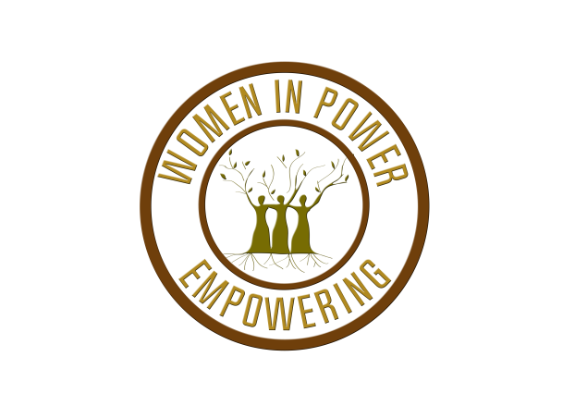
WOMEN IN POWER EMPOWERING
2019 BUSINESS EMPOWERMENT AWARD
Funding Application

The mission of Women in Power Empowering is to create opportunities for women to overcome obstacles by providing financial awards, mentoring, and support. Our vision is to create a community of women empowering women.
The Business Empowerment Award was established to assist women business owners and nonprofit founders with growing their small business or organization.
Who should apply?
Women who own their own business or have founded a non-profit that meet the following criteria:
- Has annual operating expenses not exceeding $100,000; AND
- Has been a registered entity with the Texas Secretary of State at least 1 year prior to December 2019.
How to apply?
Submit the attached application with the following documentation:
- Current year operating budget
- Verification of business structure (i.e. IRS Exemption Letter, SOS Certificate of Filing)
- Additional supporting documents (e.g. marketing materials, pictures of your product/events/services, etc.)
Submit to: womeninpowerempowering@gmail.com or mail to Women In Power Empowering at P.O. Box 8896, Fort Worth, TX 76124.
Application submission deadline: September 30, 2020 by 11:59 PM CST. Applications submitted via mail must be postmarked no later than September 30, 2020.
Awarded funds will be paid directly to the company awarded. No funds will be paid to individuals. Those awarded must be available to attend the Virtual Empowerment Event in October, more details will be provided.
Award availability
The total amount awarded in 2020 funding cycle is $1, 000.
Awards will be announced October 17, 2020. Awardees will be notified by phone and email. Awardees unable to be contacted by October 19, 2020 will be disqualified.

WOMEN IN POWER EMPOWERING
2019 BUSINESS EMPOWERMENT AWARD
Funding Application

Business Name

Address City State Zip

Phone Alternate Phone Email

Primary Contact Name

Business Type (Select One) ⃝ For Profit ⃝ Non-profit

Provide answers to the following questions in WORD or PDF Format.

- What is the mission/purpose of your business or organization?
- Do you provide goods or services? Please describe in detail.
- How do people hear about your business (i.e. Facebook, website, word-of-mouth)?
- How can your business benefit the community?
- If awarded, how will these funds be used?
- How can your business or organization partner with Women in Power Empowering in the future to empower women?

